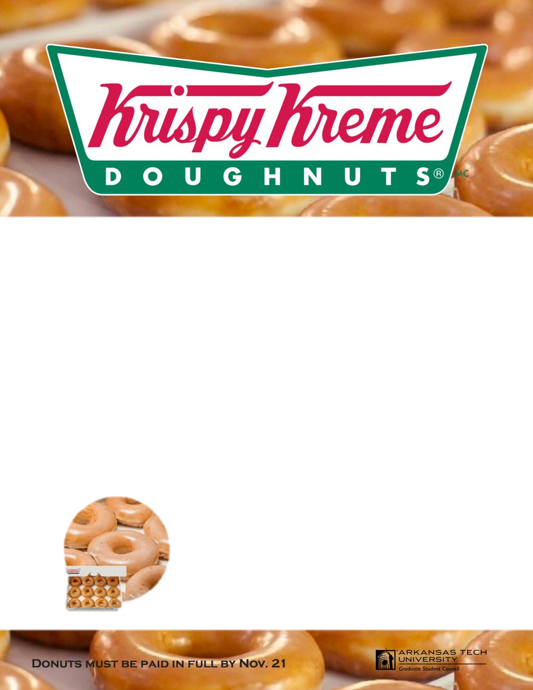

#### To Order, e-transfer:

##### **hughmcrobertspac@gmail.com**

with the information:

* **Purchaser’s Name**
* **Phone #** (in case we need to contact you)
* **Student’s Name**
* **Quantity**

**We will be accepting payments through e-Transfers & Cheques.**

Cheques made payable to “Mc Roberts PAC”

and can be dropped off at the Office.

PRE-ORDER for

Fri. Dec. 8th

Pac Fundraiser

PICK UP: Main entrance – 8am, 3pm

In the foyer – 12:50pm

$15/Dozen   
(12 pk)

$28/Two Dozen

Help us raise some dough for your School.

Treat your friends & family to Krispy Kreme Original Glazed Doughnuts!

**来买甜甜圈**

**PRE-ORDER BY Wed. Dec 6th!**

There will be LIMITED QUANTITIES on DEC. 8th to be purchased by CASH as well as SINGLE DOUGHNUTS for $2 each OR THREE DOUGHNUTS for $5.

before and after school until all is sold.