MCROBERTS CLC/CAPSTONE 2022-2023
COURSE OUTLINE
Teachers: Mme Hudson, Mme Mainville, Mr. Malchy & Mr. McBurney

What is Capstone? (*From Ministry of Education website)

The capstone is a rigorous learning opportunity that allows students to reflect and share in personally meaningful ways and is a requirement for Career-Life Connections and for graduation. The purpose of the capstone is to let students demonstrate the knowledge, competencies, and passion(s) that they can offer the world, as they integrate personal interests, strengths, and new learning with preferred future possibilities. It is a deeper learning experience that supports the student’s continued learning journey into post-graduation possibilities and provides an opportunity to reflect and synthesize as well as showcase and celebrate.
The capstone components are an opportunity for students to further develop and showcase their strengths, passions, and learning journey to a relevant audience. As a celebration of their learning journey, the capstone is a place where students are encouraged to share successes both in school and out of school, including their reflections on Core Competency development, their contributions and aspirations, and via a CLC assignment, their possible plans for post-graduation. The capstone can take many different forms, depending on student needs and interests and the opportunities available in local school communities.
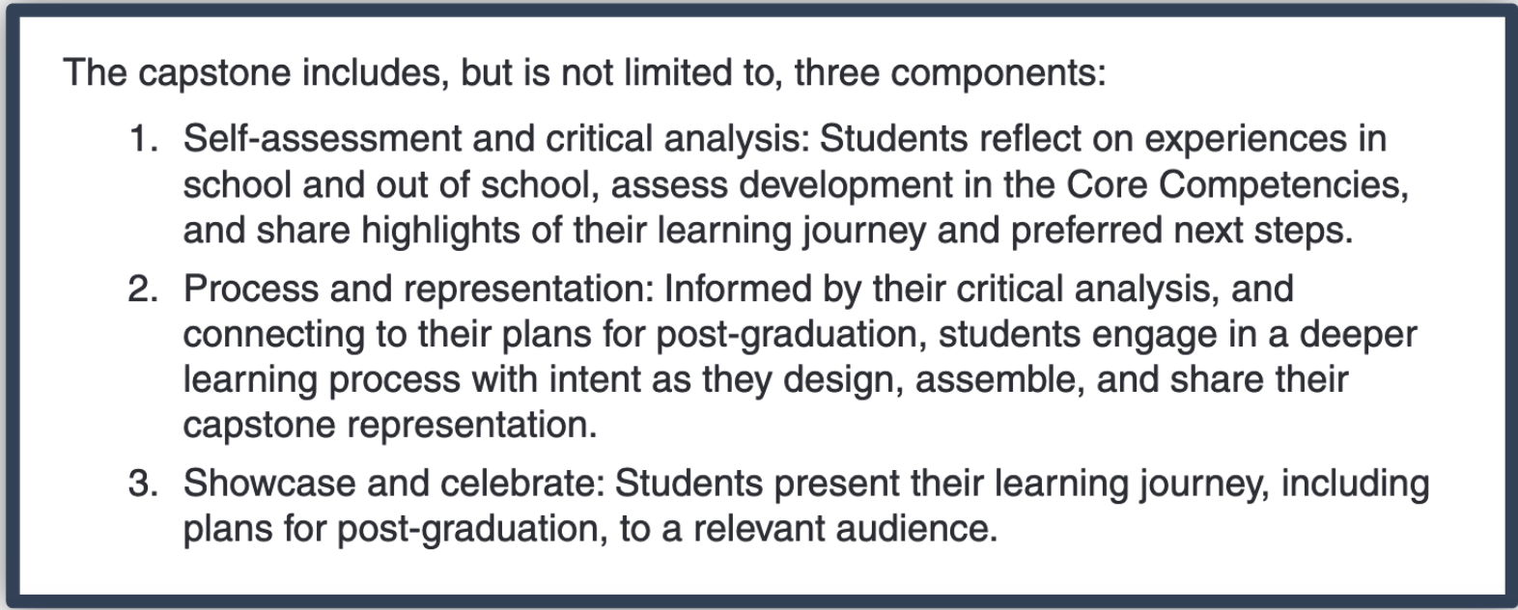

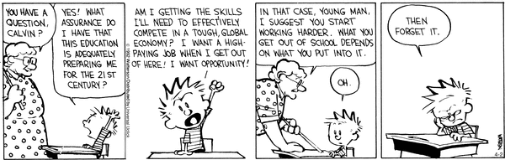

Why are we doing it?

The entire CE program is an effort to better prepare you for life, both personal and work, after high school. Capstone projects help to develop a range of skills and give students choice to pursue what is most interesting and relevant for them. Your project may lead you to certain understandings about what you want to, or don’t want to, do after high school.

Why is Career Education structured the way it is? How are the parts related?

Career Education has several parts to it that occur over your five years at McRoberts. Career Life Education (CLE)/Éducation à la carrière (EC) is the one part of the career education program that involves a class that is part of your timetable- in grade 11 at McRoberts. CLE provides the opportunity to go deeper and get direct support from a teacher. Career Life Connections (CLC) is a graded course that students take in grade 12, but not one that is part of your timetable. It will prepare you in a more general way for life after high school. Capstone project is part of CLC. Personal Learning Time (PLT) is the timetable structure that CLC teachers will use to meet with you in person. In addition, you will have mandatory in-person meetings with your CLC teacher on the following dates in September and October.

Wednesday September 14th PLT
Thursday September 29th PLT
Wednesday October 5th PLT

How will these projects be assessed? Who will grade them?

Your assignments will be graded by your CLC/Capstone teacher. Assessment will be both formative and summative. Your grade for the course will be broken down as follows:

ASSIGNMENT | VALUE
Learning Logs 4 logs  Due Dates:  LL#1 – Friday October 7th /2022  Capstone Pitch – October 24 - November 4 (Not graded)  LL#2 – Friday November 25/2022  LL#3 – Friday January 20/2023  LL#4 – Friday February 24/2023 | 40%
Final Showcase Project & Final Reflection (April 20/2023) | 25%
CLC Assignments x4 (April-June)  - Video Interview (May have completed last year)  - Career Connections  - Inclusion/Diversity in the workplace  - Networking | 35%

What supports are available?

The Career Education implementation team is made up of Mme Hudson, Mme Mainville, Mr. Malchy, Mr. McBurney, and Mr. Li. You can speak to them about any questions you have. This year, CLC teachers are available during PLT every Wednesday and, Thursday is a great time to get some work done. PLT will play an important role in completing your CLC requirements. Most of all, the assignments you complete will guide you. For this reason, it is very important that you don’t miss or skip assignments, as each one builds on what was completed in the previous assignment.

Here is where you can find your teachers:

Mme Hudson (jahudson@sd38.bc.ca) LIBRARY
Mme Mainville (jmainville@sd38.bc.ca) LIBRARY
Mr. Malchy (jmalchy@sd38.bc.ca) PORTABLE 3
Mr. McBurney (mmcburney@sd38.bc.ca) ROOM 206

