CLC/CAPSTONE

**CAPSTONE PITCH**

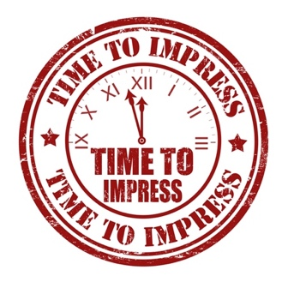It is now time for you to pitch your Capstone project idea to your CLC12 teacher for final approval of your personal inquiry project. At this point in your journey, you have chosen a topic, created an essential question, decided on a process, and have done some research for your first learning log. Next, you need to reflect on and prepare answers to the following questions in preparation for your pitch conversation, and set out your timeline for learning. You will be contacted by your CLC teacher to set up a meeting time to discuss your answers to these questions and go over your timeline.

**PART A: REFLECT & PREPARE ANSWERS TO THESE 5 QUESTIONS**

1. What is your essential question? Describe what you are hoping to learn from this project and why you are inspired by your topic. Why is it important to you?
2. How do you plan to answer your essential question? What process makes the most sense?
3. How will you access all the necessary resources to get this project done? What resources have you already found? (Artifacts, literature, media, mentors, etc.)
4. Identify any limitations of your project. What potential obstacles do you foresee?
5. What impact do you think your research will have on your community or the world at large?

**PART B: YOUR WORK PLAN**

Based on the Process(es) that you’ve chosen, identify which steps you intend to complete by the due date of each Learning Log?

|  |  |
| --- | --- |
| **Learning Log #1**  **(Oct 10)** | **Provide a list below of what you plan on having done by this date.** |
| **Learning Log #2**  **(Nov 14)** | **Provide a list below of what you plan on having done by this date.** |
| **Learning Log #3**  **(Dec 12)** | **Provide a list below of what you plan on having done by this date.** |
| **Learning Log #4**  **(Feb 6)** | **Provide a list below of what you plan on having done by this date.** |