MCROBERTS CLC/CAPSTONE 2026-2027
COURSE OUTLINE

What is Capstone? (*From Ministry of Education website)
The Capstone is a rigorous learning opportunity that allows students to reflect and share in personally meaningful ways and is a requirement for Career-Life Connections and for graduation. The purpose of the Capstone is to let students demonstrate the knowledge, competencies, and passion(s) that they can offer the world, as they integrate personal interests, strengths, and new learning with preferred future possibilities. It is a deeper learning experience that supports the student’s continued learning journey into post-graduation possibilities and provides an opportunity to reflect and synthesize as well as showcase and celebrate.

The Capstone components are an opportunity for students to further develop and showcase their strengths, passions, and learning journey to a relevant audience. As a celebration of their learning journey, the Capstone is a place where students are encouraged to share successes both in school and out of school, including their reflections on Core Competency development, their contributions and aspirations, and via a CLC assignment, their possible plans for post- graduation. The Capstone can take many different forms, depending on student needs and interests and the opportunities available in local school communities.

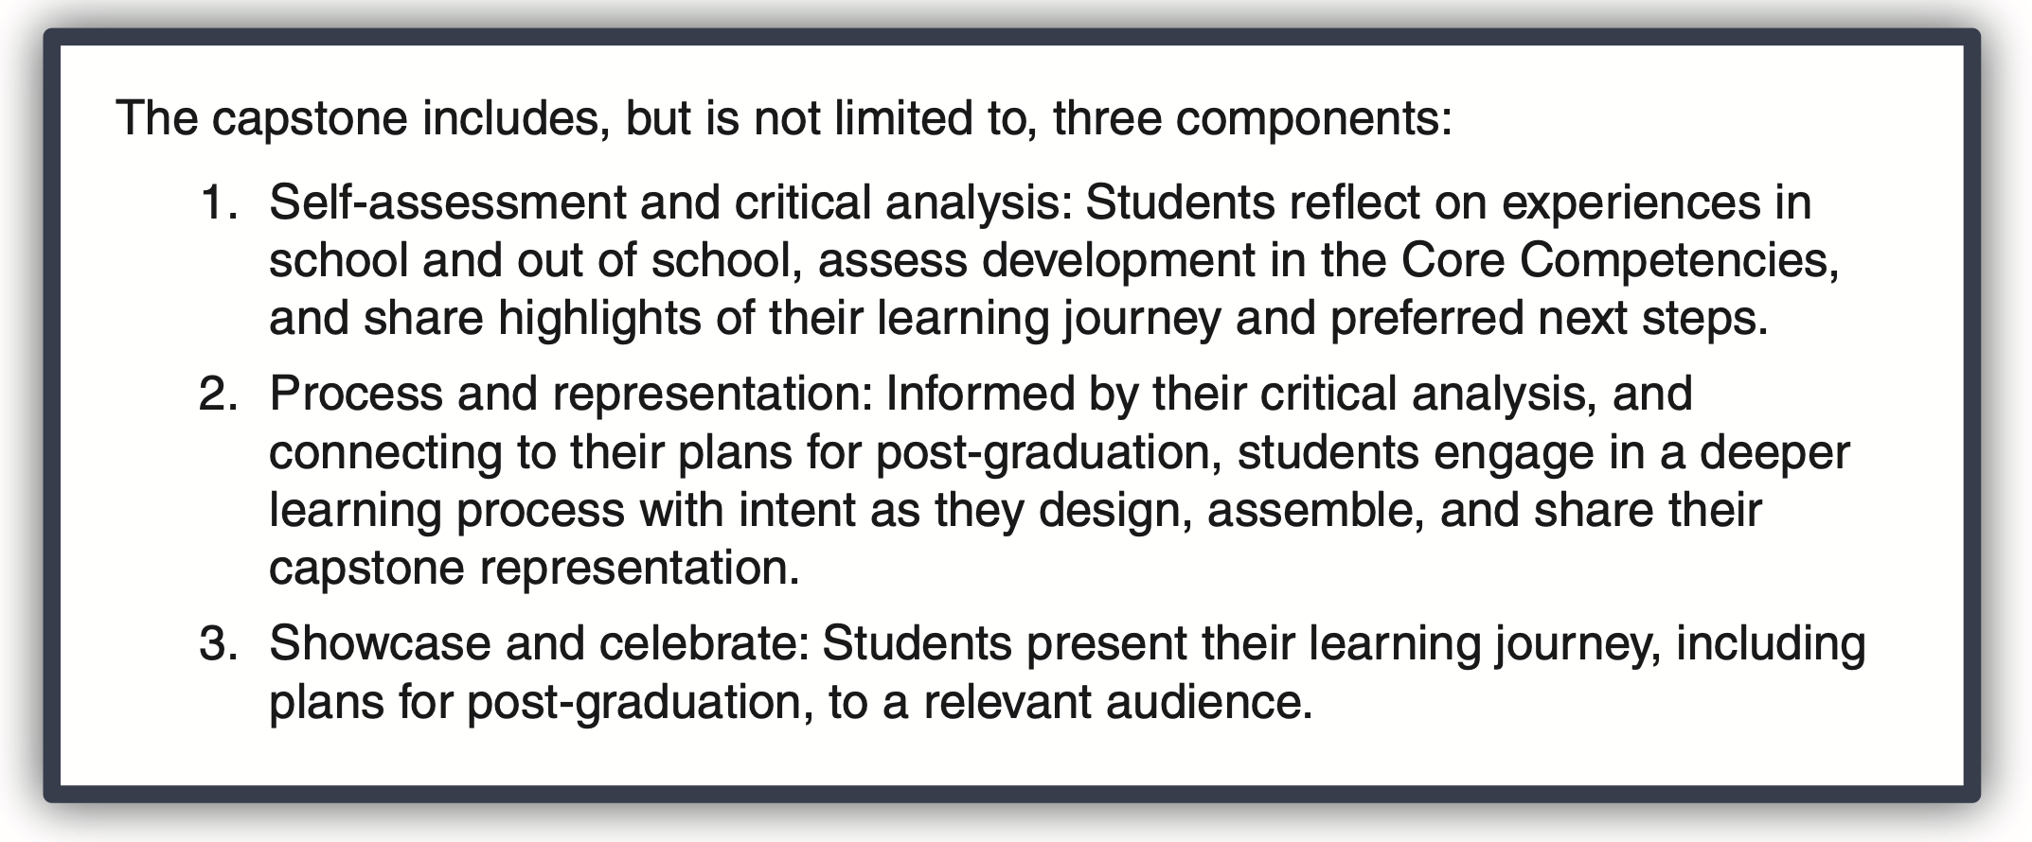

Why are we doing it?
The entire Career Education program is an effort to better prepare you for life, both personal and work, after high school. Capstone projects help to develop a range of skills and give students choice to pursue what is most interesting and relevant for them. Your project may lead you to certain understandings about what you want to, or don’t want to, do after high school.

Why is Career Education structured the way it is? How are the parts related?
Career Education has several parts to it that occur over your five years at McRoberts. Career Life Education (CLE)/Éducation à la carrière (EC) is the one part of the career education program that involves a class that is part of your timetable, in Grade 11, at McRoberts. CLE provides the opportunity to go deeper and get direct support from a teacher. Career Life Connections (CLC) is a graded course that students take in Grade 12, but not one that is part of your timetable. It will prepare you in a more general way for life after high school. The Capstone project is part of CLC. Personal Learning Time (PLT) is the timetable structure that CLC teachers will use to meet with you in person. In addition, you will have mandatory in-person meetings with your CLC teacher on the following dates to be determined in September.

One on one meetings will be scheduled as needed either by teacher or student.

How will these projects be assessed? Who will grade them?
Your assignments will be graded by your CLC/Capstone teacher. Assessment will be both formative and summative. Your grade for the course will be broken down as follows:
ASSIGNMENT | VALUE
4 Learning Logs  Due Dates:  Capstone Pitch – October 9 - October 14 (Not graded)  LL#1 – Friday, October 16  LL#2 – Friday, November 20  LL#3 – Friday, December 18  LL#4 – Friday February 5 | 40%
Final Showcase Project & Final Reflection (April 16, 2027) | 20%
3 CLC Assignments (March - June)  - Inclusion/Diversity in the workplace  - Career Connections  - Networking | 30%
Work Experience/Volunteer Hours (30 hours total from grade 11 & 12) | 10%
Each assignment in this course is a key piece of evidence.
If you do not hand in an assignment, or if an assignment is assessed as EMERGING,
you will be considered “INCOMPLETE” until the work is handed in and/or is done at a satisfactory level.
What supports are available?
The Capstone/CLC Team is currently made up of Mr. Bains, Mr. Haigh, Mr. McBurney, and Ms. Tamana. You can speak to them about any questions you have. PLT will play an important role in completing your CLC requirements. Most of all, the assignments you complete and the feedback you receive will guide you. For this reason, it is very important that you do not miss or skip assignments, as each one builds on what was completed in the previous assignment.
Mr. Bains (anbains@sd38.bc.ca) Portable 3
Mr. Haigh (ghaigh@sd38.bc.ca) Rm 103
Mr. McBurney (mmcburney@sd38.bc.ca) PE Office
Ms. Tamana (mdosanjh@sd38.bc.ca) Rm 108

